Redefining Precision: Advanced RPA for Clinical Lab Data Entry

Revolutionizing Local Lab Reference Range Entry in Clinical Research through Advanced RPA Solutions

Aim

Building a Advanced RPA Model for Automated Local and Global Range Detection using Clinical Lab Result Data.

Introduction

Clinical Research Assistants are solely responsible for the entry of lab results, which are often recorded on books, making way for unwanted errors. We have created a program that can simplify the process of data entry and minimize the room for errors. We can input data manually to the program or upload a scanned PDF, which the program will easily recognise and store in a database. Further, the program will use the data to find the Local Lab Reference Range which can be very useful for further experiments. And, this can be accessed by other labs across the world. They can add their data to this database as well, which will be used by the app to calculate multiple Local Lab Reference Ranges which can all be compiled together. This document will explore the program completely, explaining its functioning.

Overview :

Task 1-> getting input as pdf files(handwritten and or or printed) for a test, extracting info from the pdf using machine learning techniques and saving resulting table into a rave database

Task 2 -> Create a GUI using Gradio to get the input files dynamically from user, interface it with our existing model, and evaluate accuracy in real time

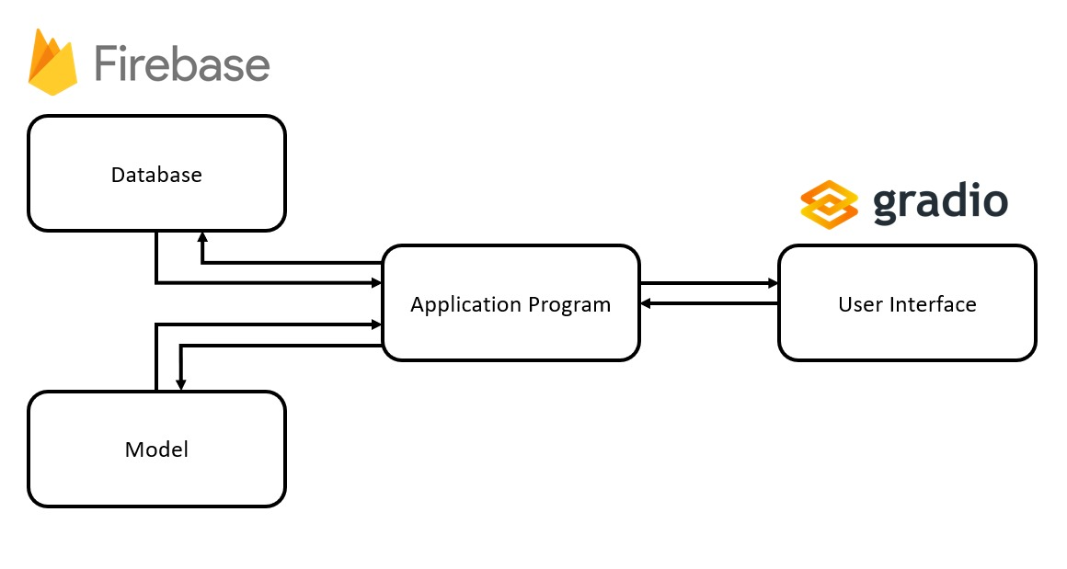

Methodology:

The Model involves getting Lab test records either as Manual Entry or by PDF Upload from the user.

The uploaded PDF is converted into a CSV File using an AI Model

which gets converted to a Pandas Dataframe.Similarly, the Manual Entry done by the user in table form from the interface is also converted into a

Pandas Dataframe.

The Dataframe is uploaded into a FireBase database where records from Laboratories across the world can be stored and accessed simultaneously.

To analyze the ranges , data is retrieved and Local Ranges is calculated separately for each lab.Entire Global Ranges of Test record parameters is also calculated for all labs after removing outliers using IQR

Model Diagram:

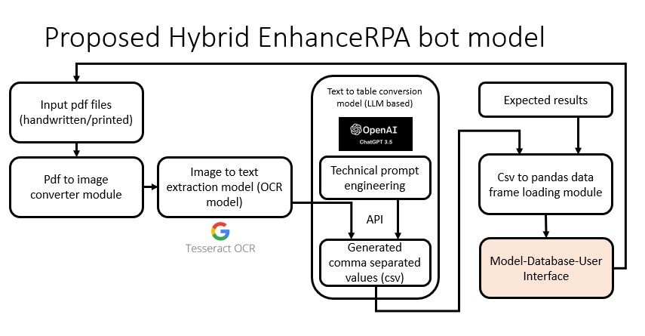

Installation:

List of Files:

app.py

db_manager.py

helper_functions.py

range.calculator.py

keys.py

README.md

<firebase.json>

Dependencies:

PIL

pdf2image

pytesseract

pandas

seaborn

matplotlib.pyplot

firebase_admin

gradio

Pathlib

openai

Demo: Manual Data Entry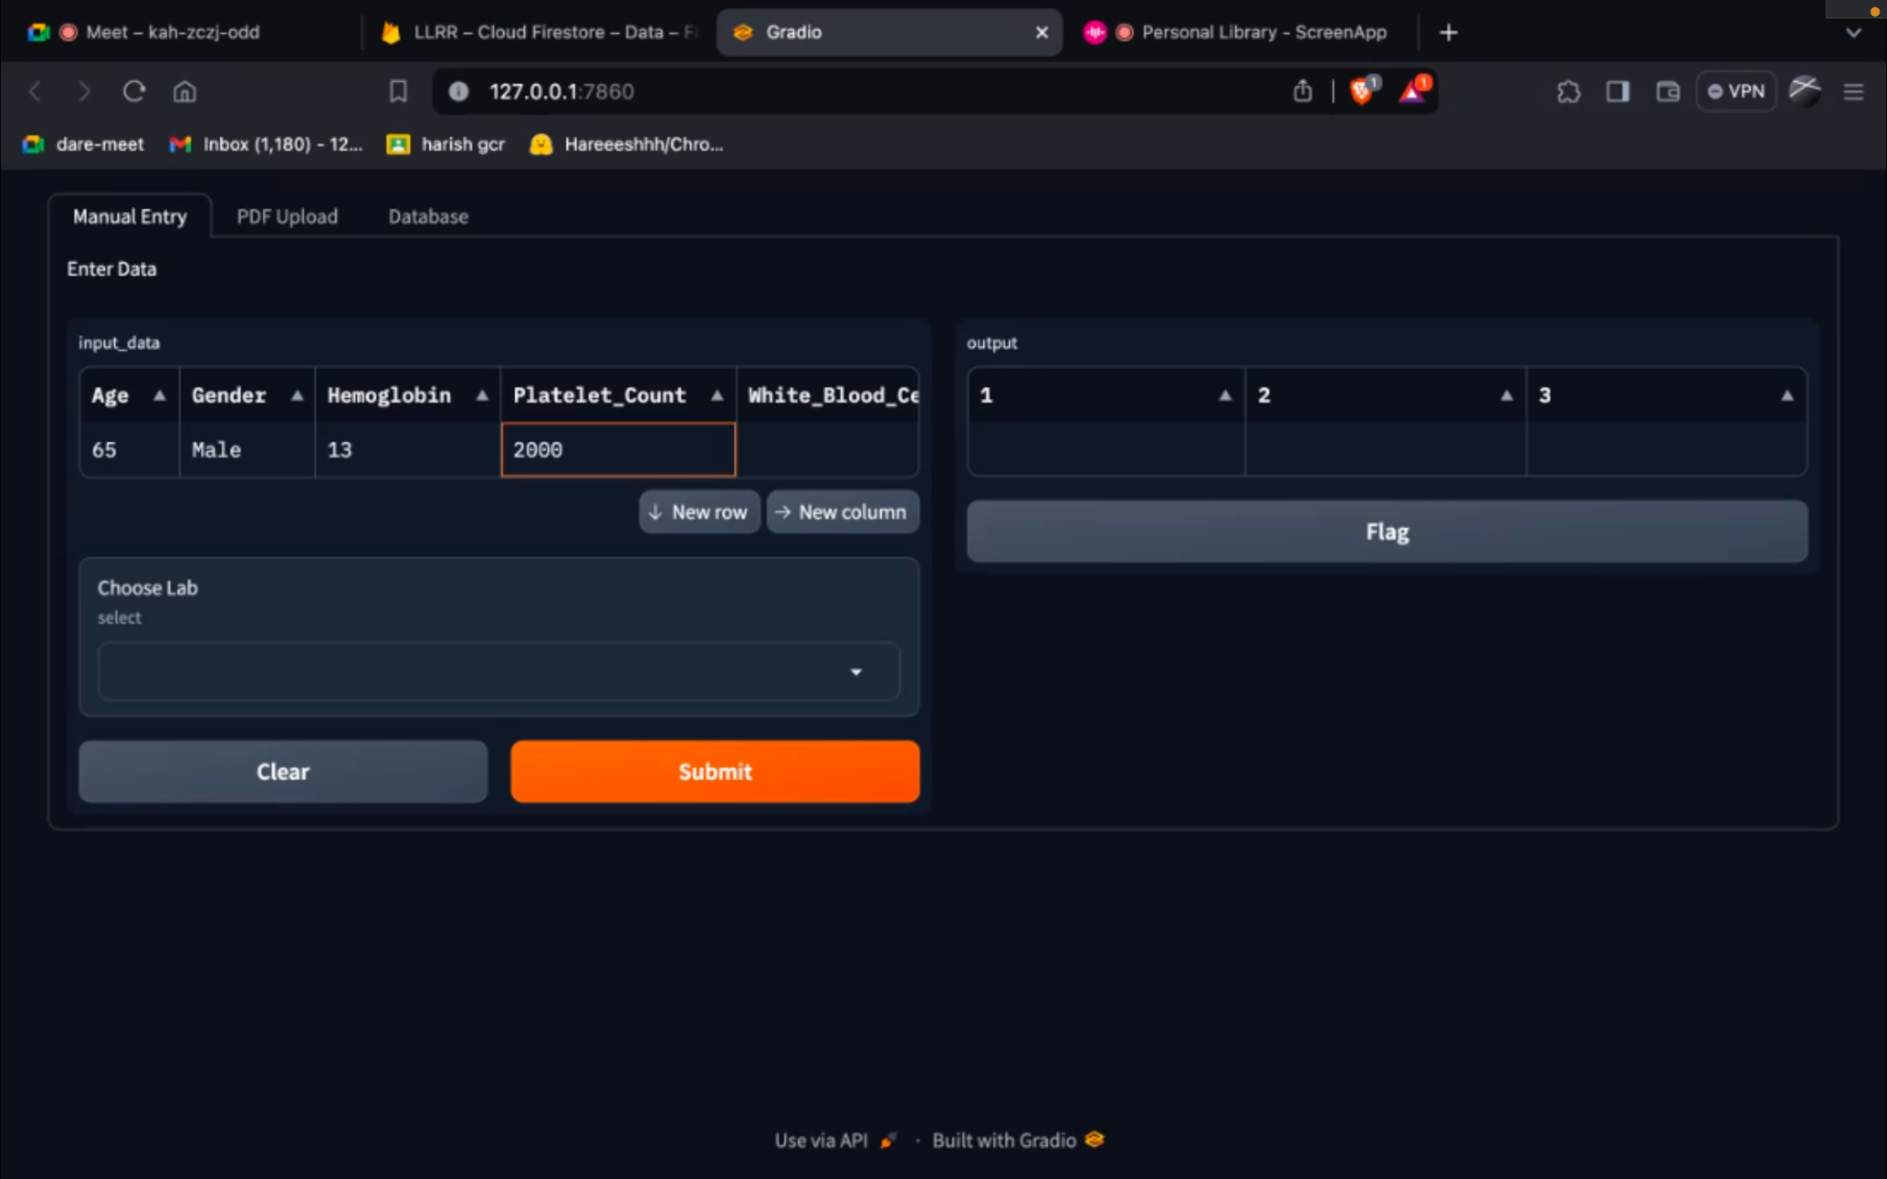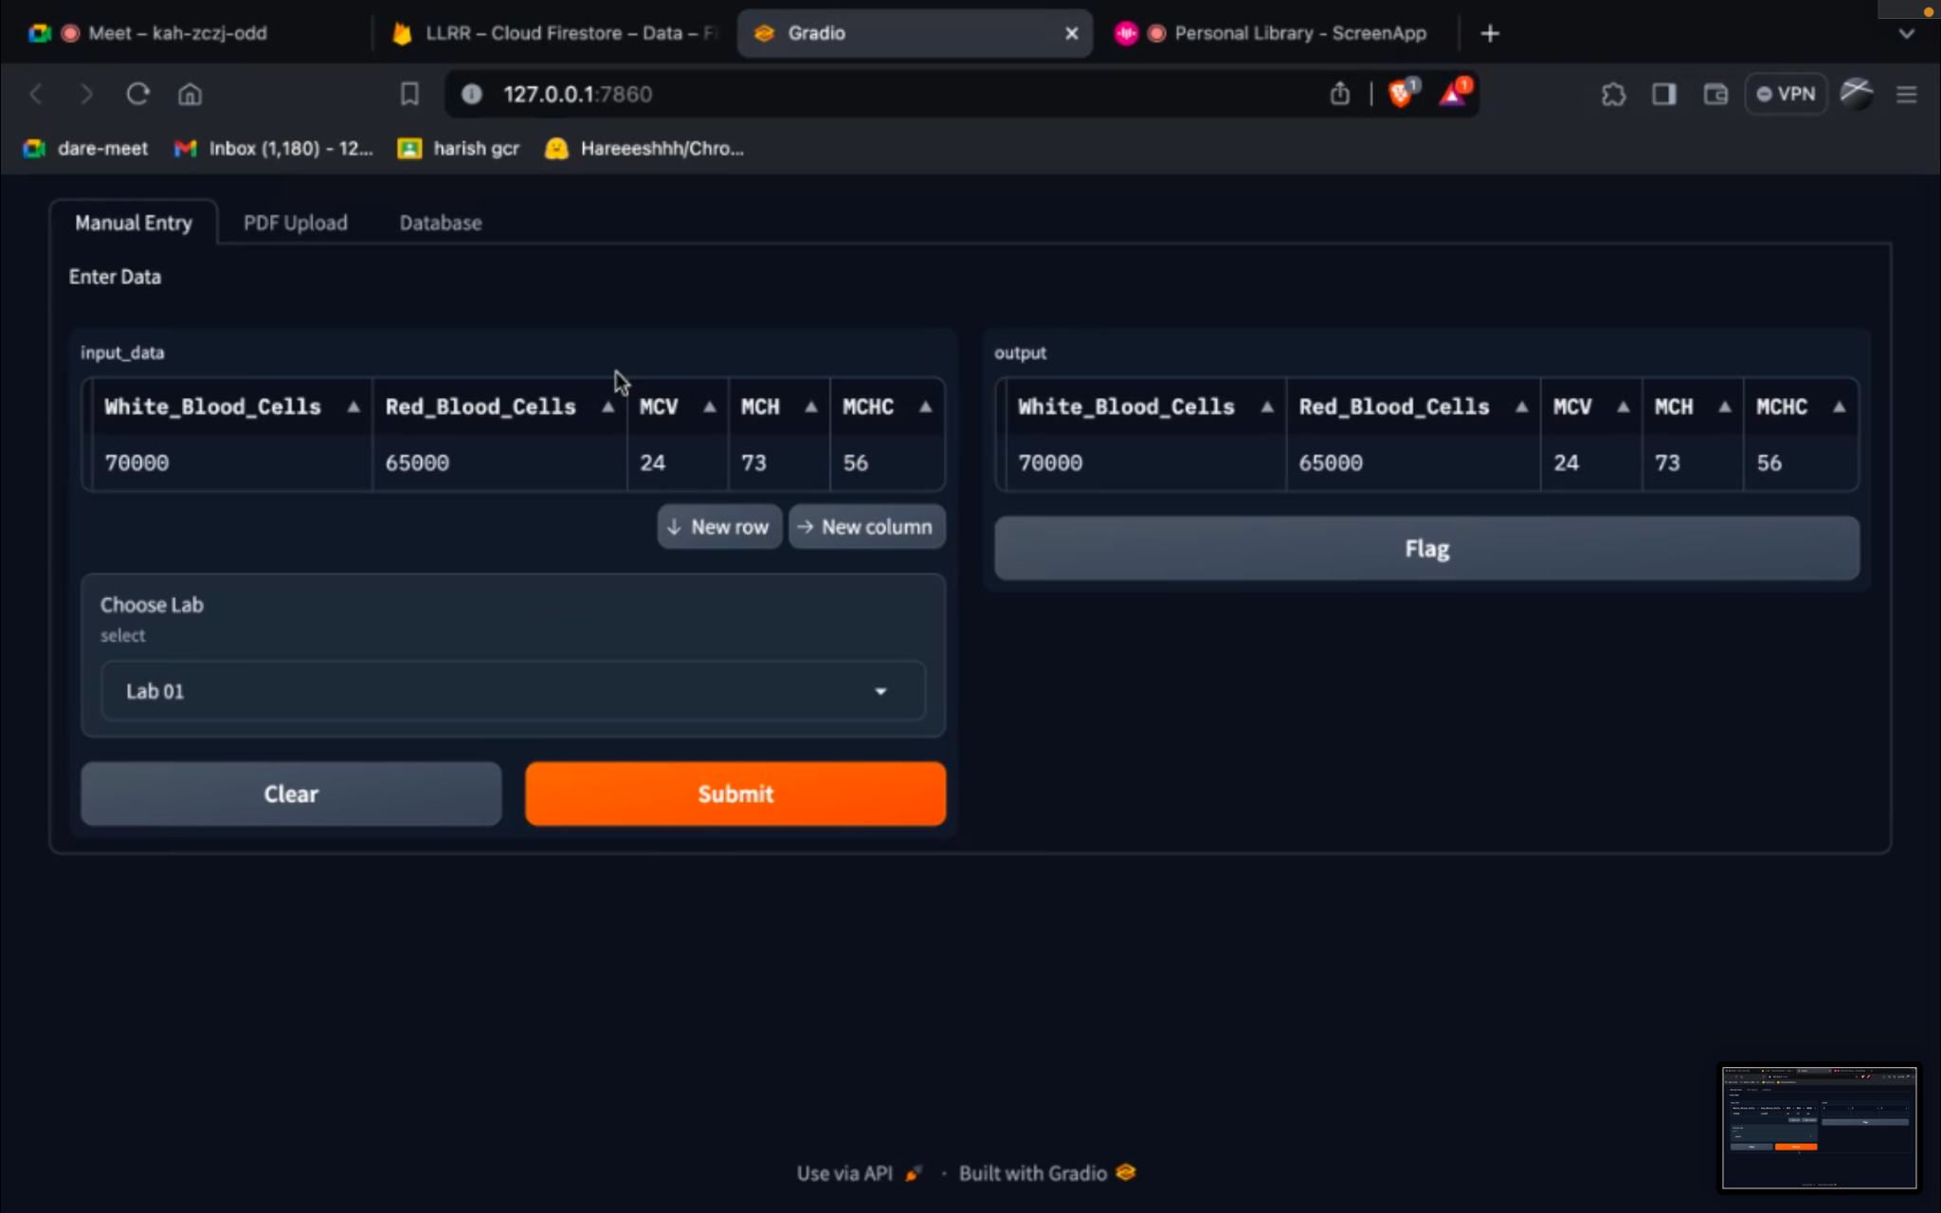

PDF Upload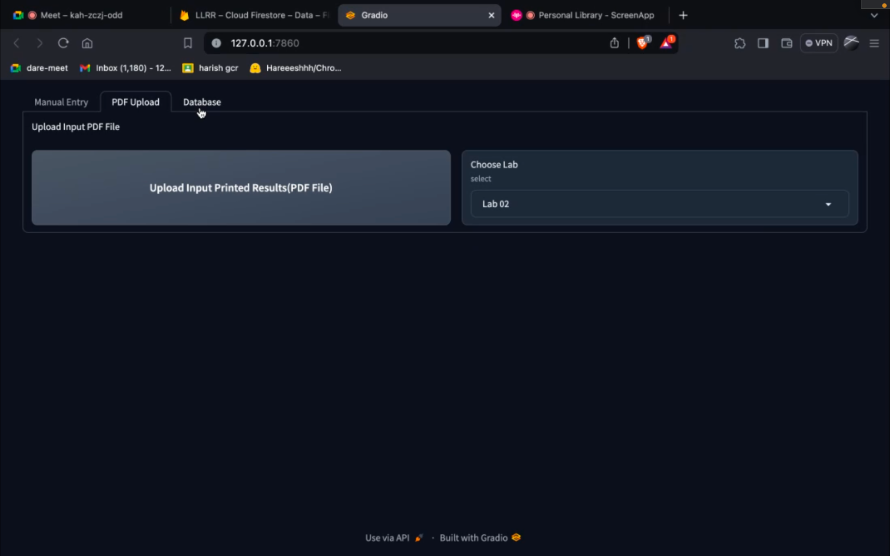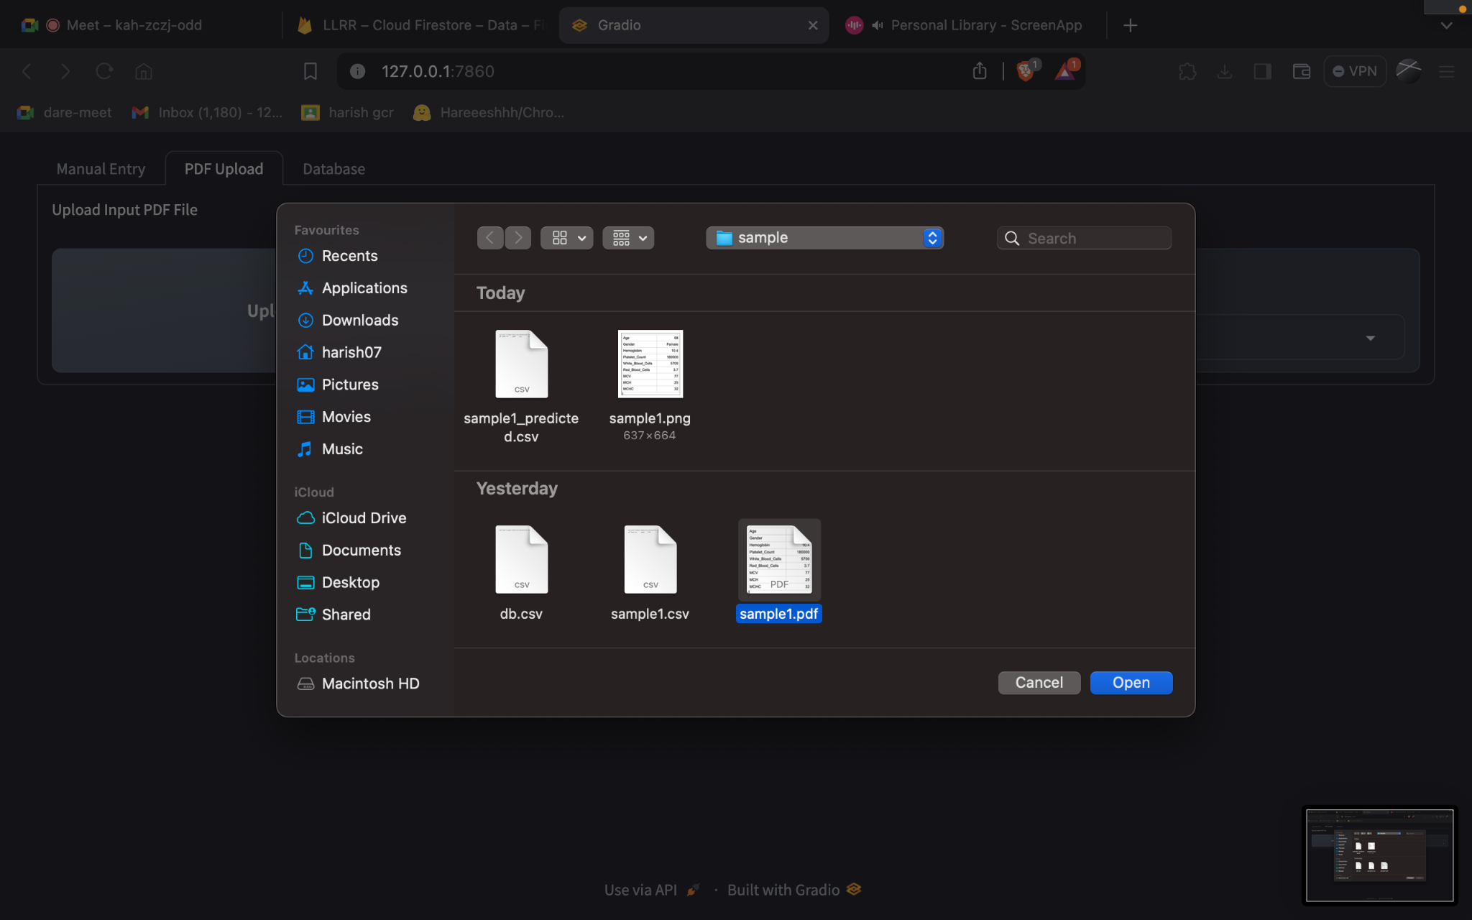

Analyzing Local Ranges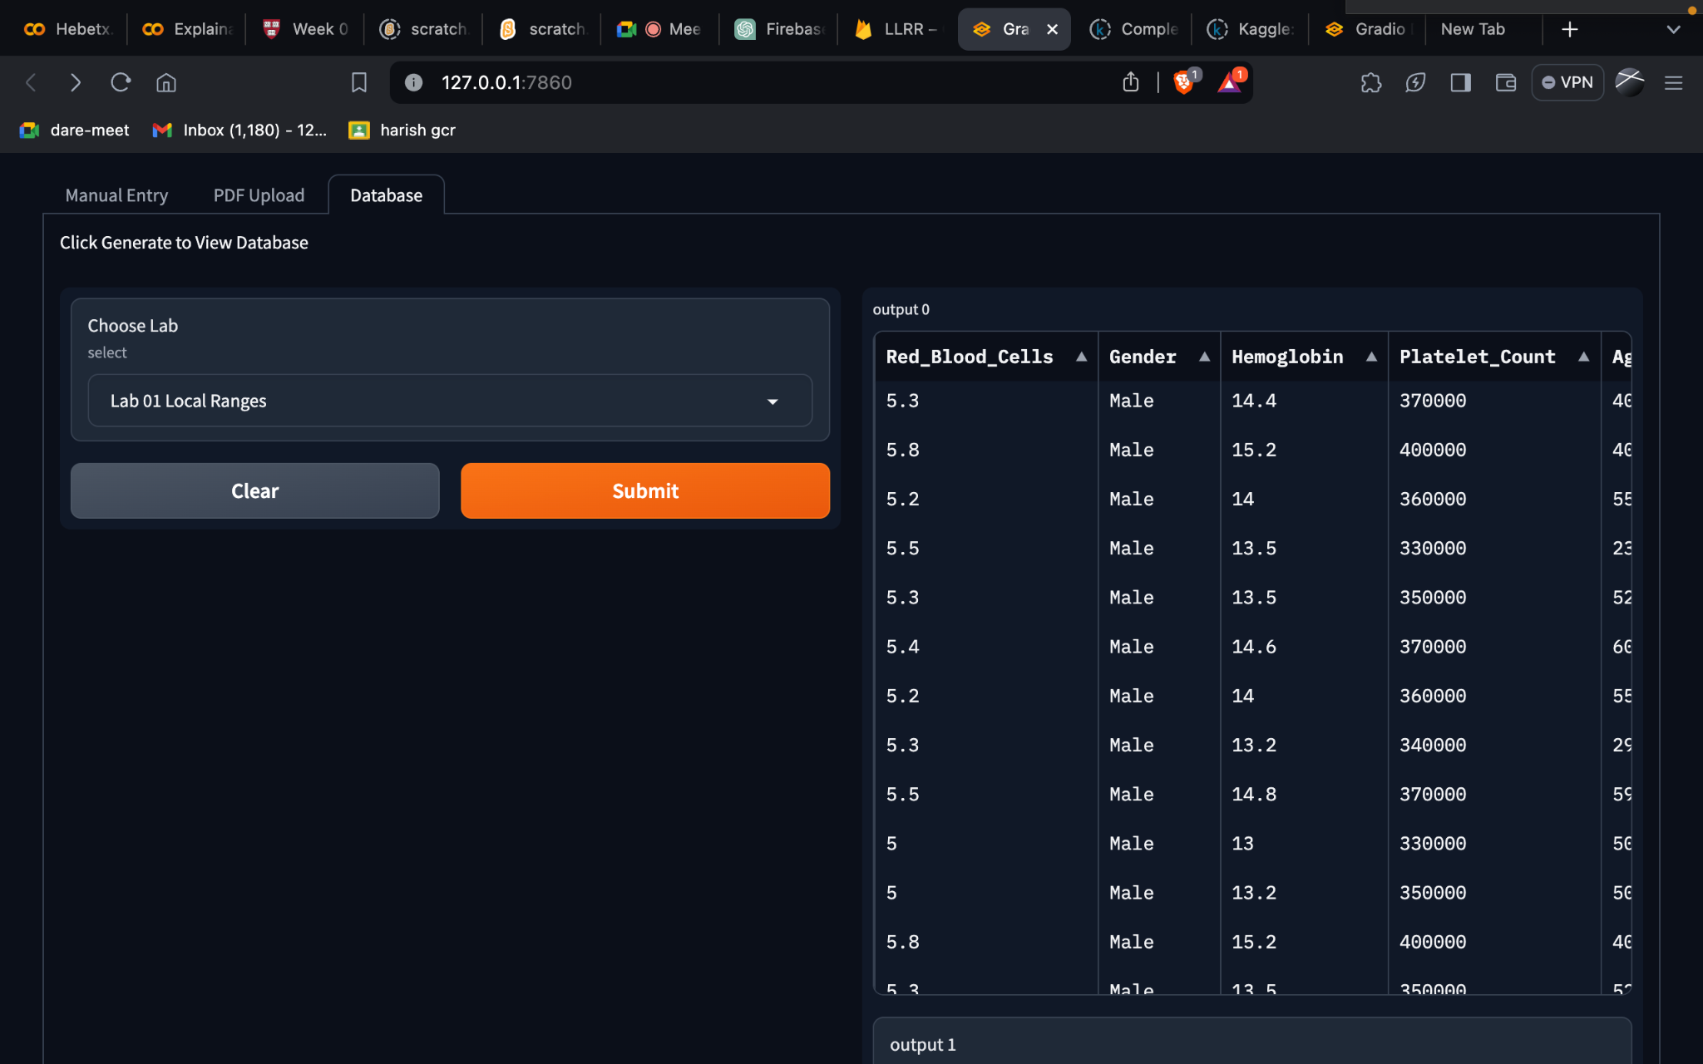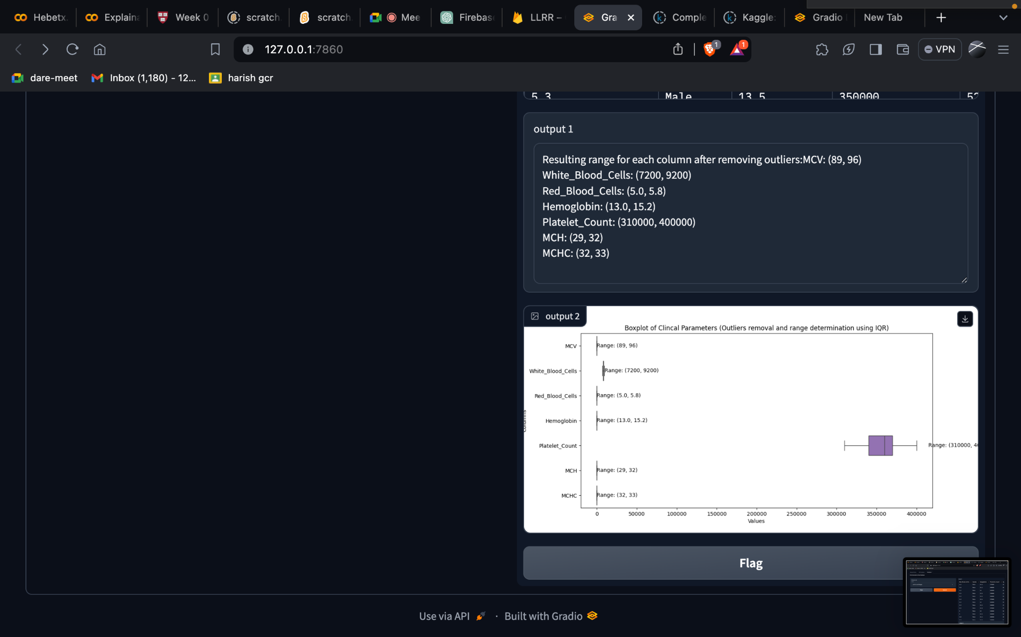

Analyzing Global Ranges

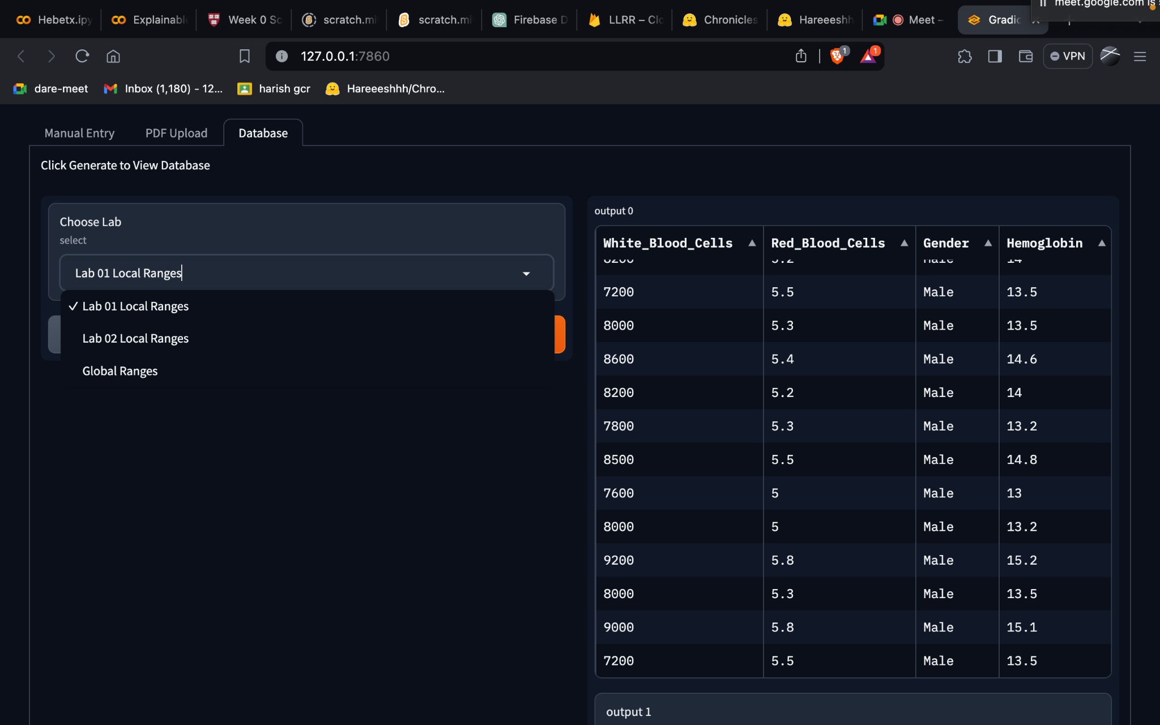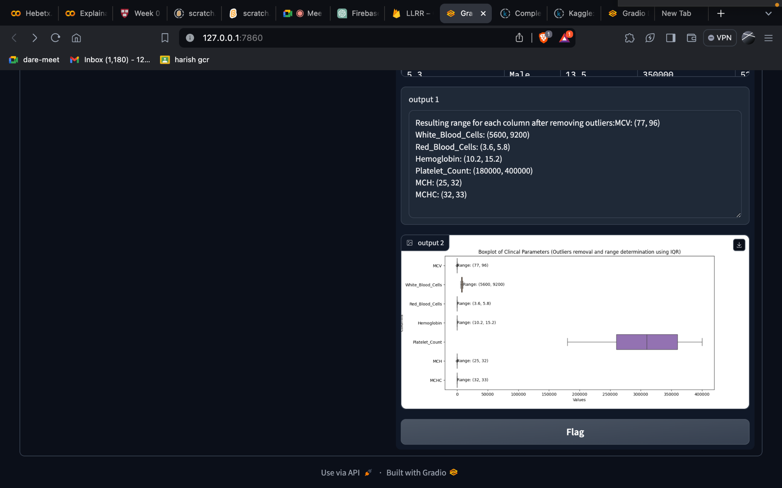

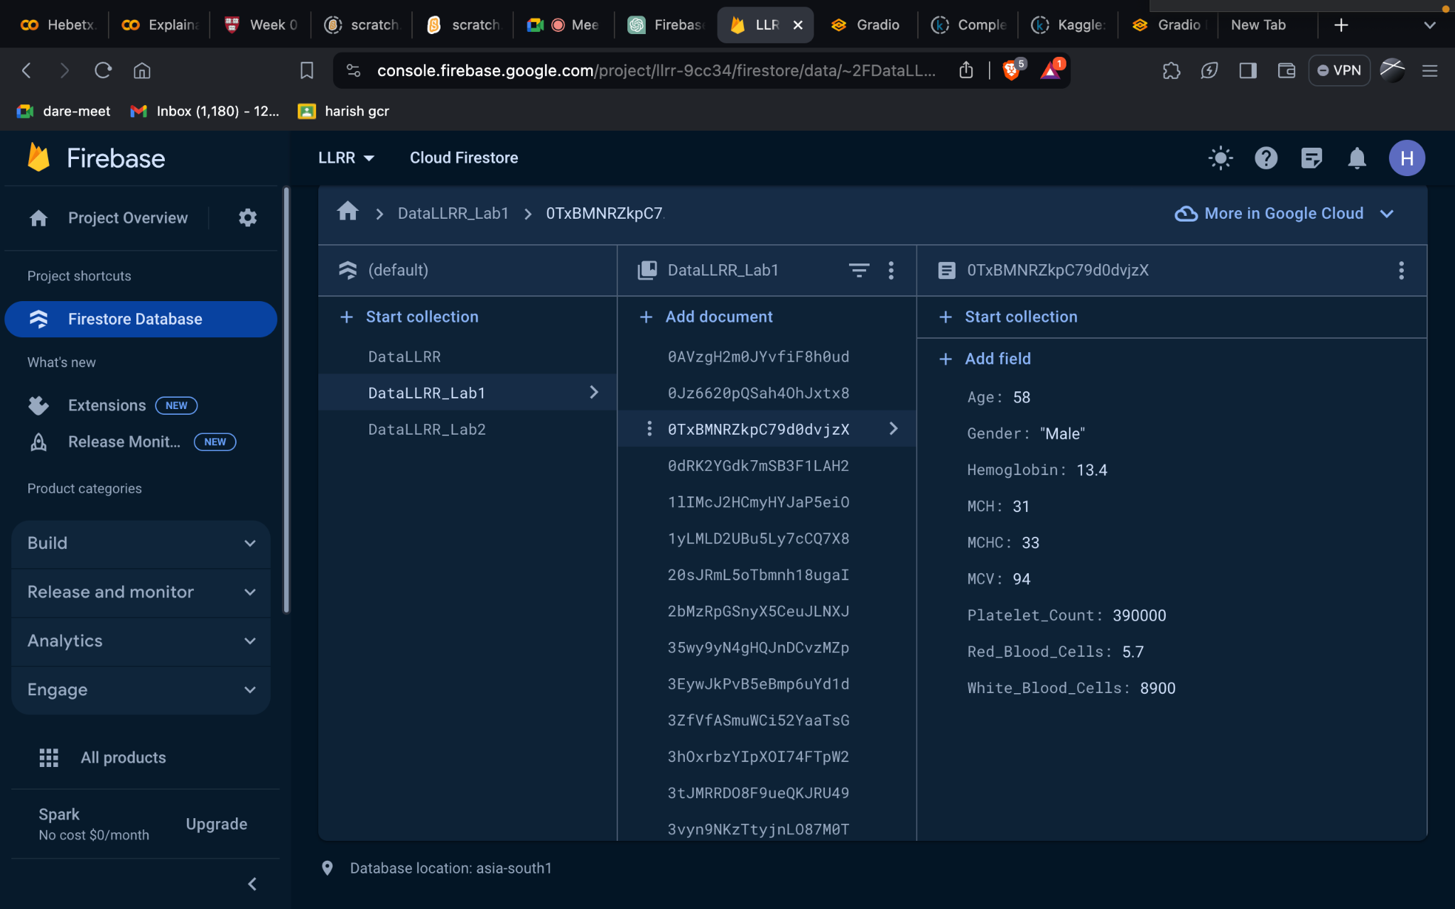

References :

<https://www.gradio.app/docs>

<https://firebase.google.com/docs>